OPSEC AND COMSEC

PREPARE A PLATOON EARLY WARNING
SYSTEM AN/TRS-2 FOR OPERATION
071-331-1000

CONDITIONS

Given a platoon early warning system (PEWS) with batteries and wire.

STANDARDS

Correctly assemble receivers and detectors for wire or radio-frequency (RF) mode.

TRAINING AND EVALUATION
Training Information Outline

Note: The PEWS is to be used by platoons, squads, or patrols. The receiver detects, locates, and classifies approaching personnel or vehicles to a maximum range of 1,500 meters. Each detector has a maximum detection range of 10 meters. (See TM 11-5895-1047-10 for additional information.)

1. Introduction to components.
a. Each PEWS consists of two bags. Within each bag (Figure 1) is a receiver (Figure 2, page 3-96), antenna and adapter (Figure 3, page 3-96), headset (Figure 4, page 3-96), five detectors (Figure 5, page 3-96), wire link (Figure 6, page 3-97), grounding rod (Figure 7, page 3-97), a pouch containing ten grounding spikes for the detectors, and five detector antennas.

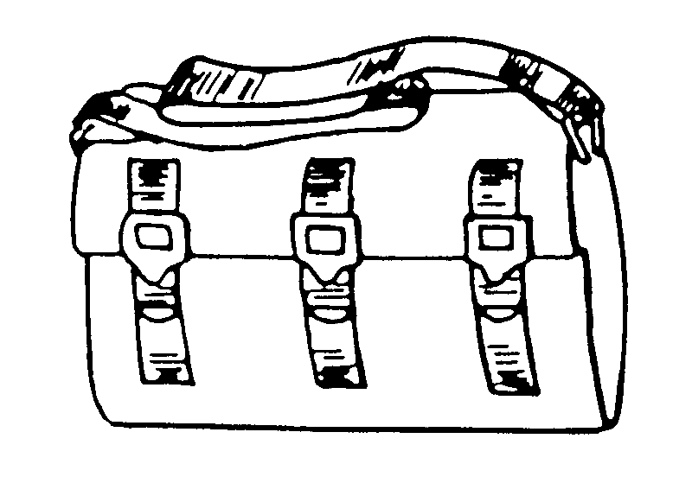

Figure 1. PEWS carrying bag.

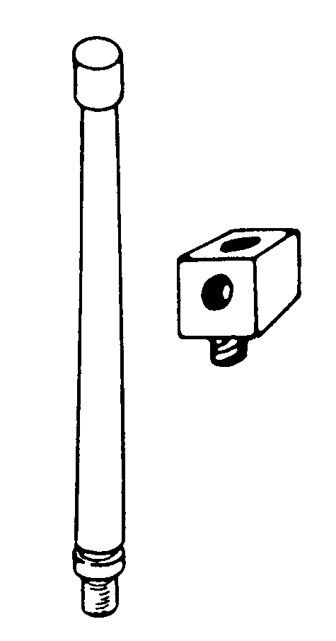
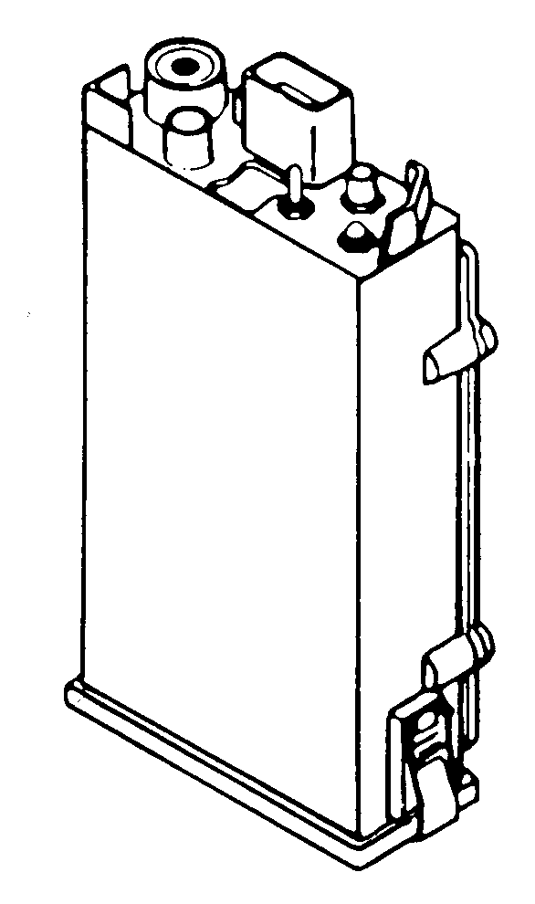

Figure 2. Receiver. Figure 3. Antenna and adapter.

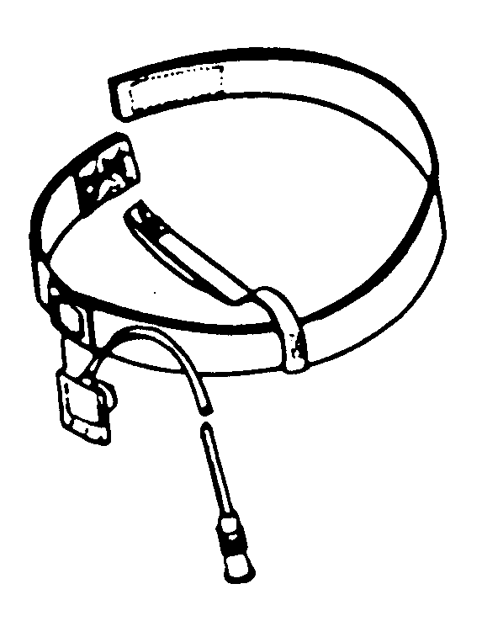

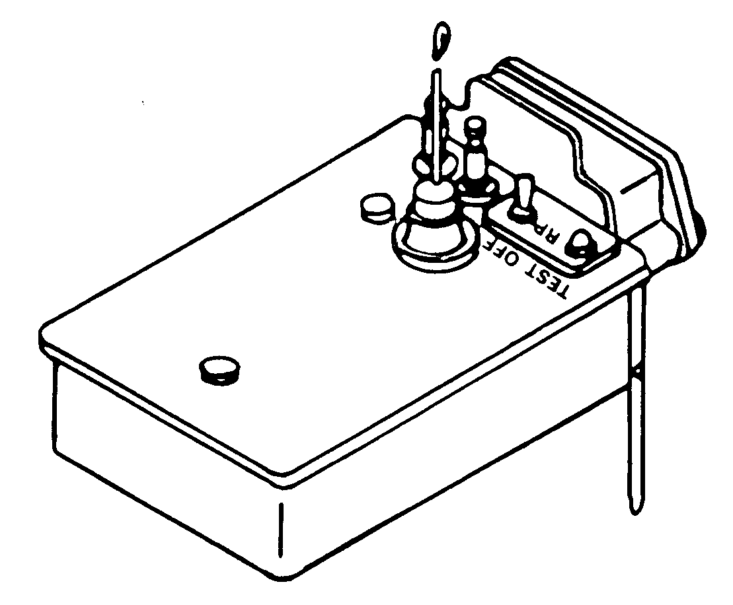

Figure 4. Headset. Figure 5. Detector.

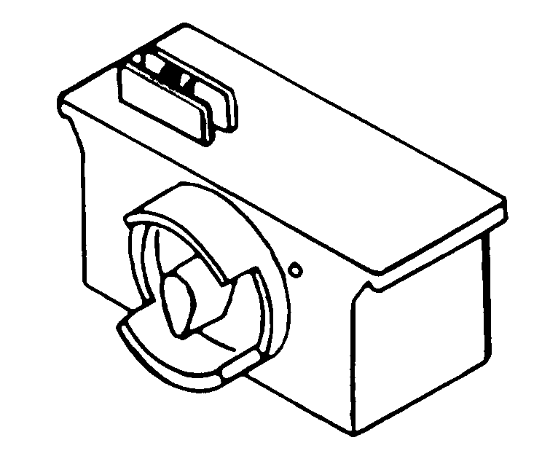

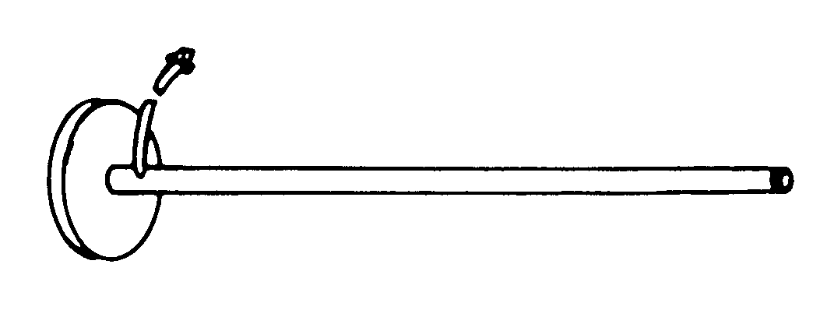

Figure 6. Wire link. Figure 7. Grounding rod.

Note: Add a TE-33 tool kit (pliers, TL-13A; knife, TL-29; and leather pouch) to one of the two bags.

b. Operation of each receiver requires two batteries (BA-90 or BA-3090). Operation of each detector requires one battery (BA-90 or BA-3090) and wire (WD-36), in addition to the components in each bag.

Note: BA-90 batteries are used when temperature is above 40 degrees F (5 degrees C), and BA-3090 batteries are used from 23 degrees F (-5 degrees C) to 40 degrees F (4.4 degrees C). When working below 23 degrees F (-5 degrees C), the operator should be aware that battery life will decrease as the temperature goes below that reading. Table 1 shows normal battery life.

TEMPERATURE RANGE | BATTERY | RECEIVER | DETECTOR
Above 40 degrees F (5 degrees C) | BA-90 | 3 days | 14 days
23 to 40 degrees F  (-5 to +5 degrees C) | BA 3090 | 3 days | 16 days

Table 1. Normal battery life.

CAUTION
Dispose of all belt links and spent brass IAW unit SOP.

2. Use of operator’s controls.
a. Receiver (Figure 8).
(1) The display (DSPL) window (1, Figure 8) shows the identification number of the detector(s) transmitting to the receiver when the detector has been activated and shows the type of intruder. The first two digits shown are identification numbers (1 to 16), and the last digit will be either a “P” (personnel intruder) or “C” (vehicle intruder).

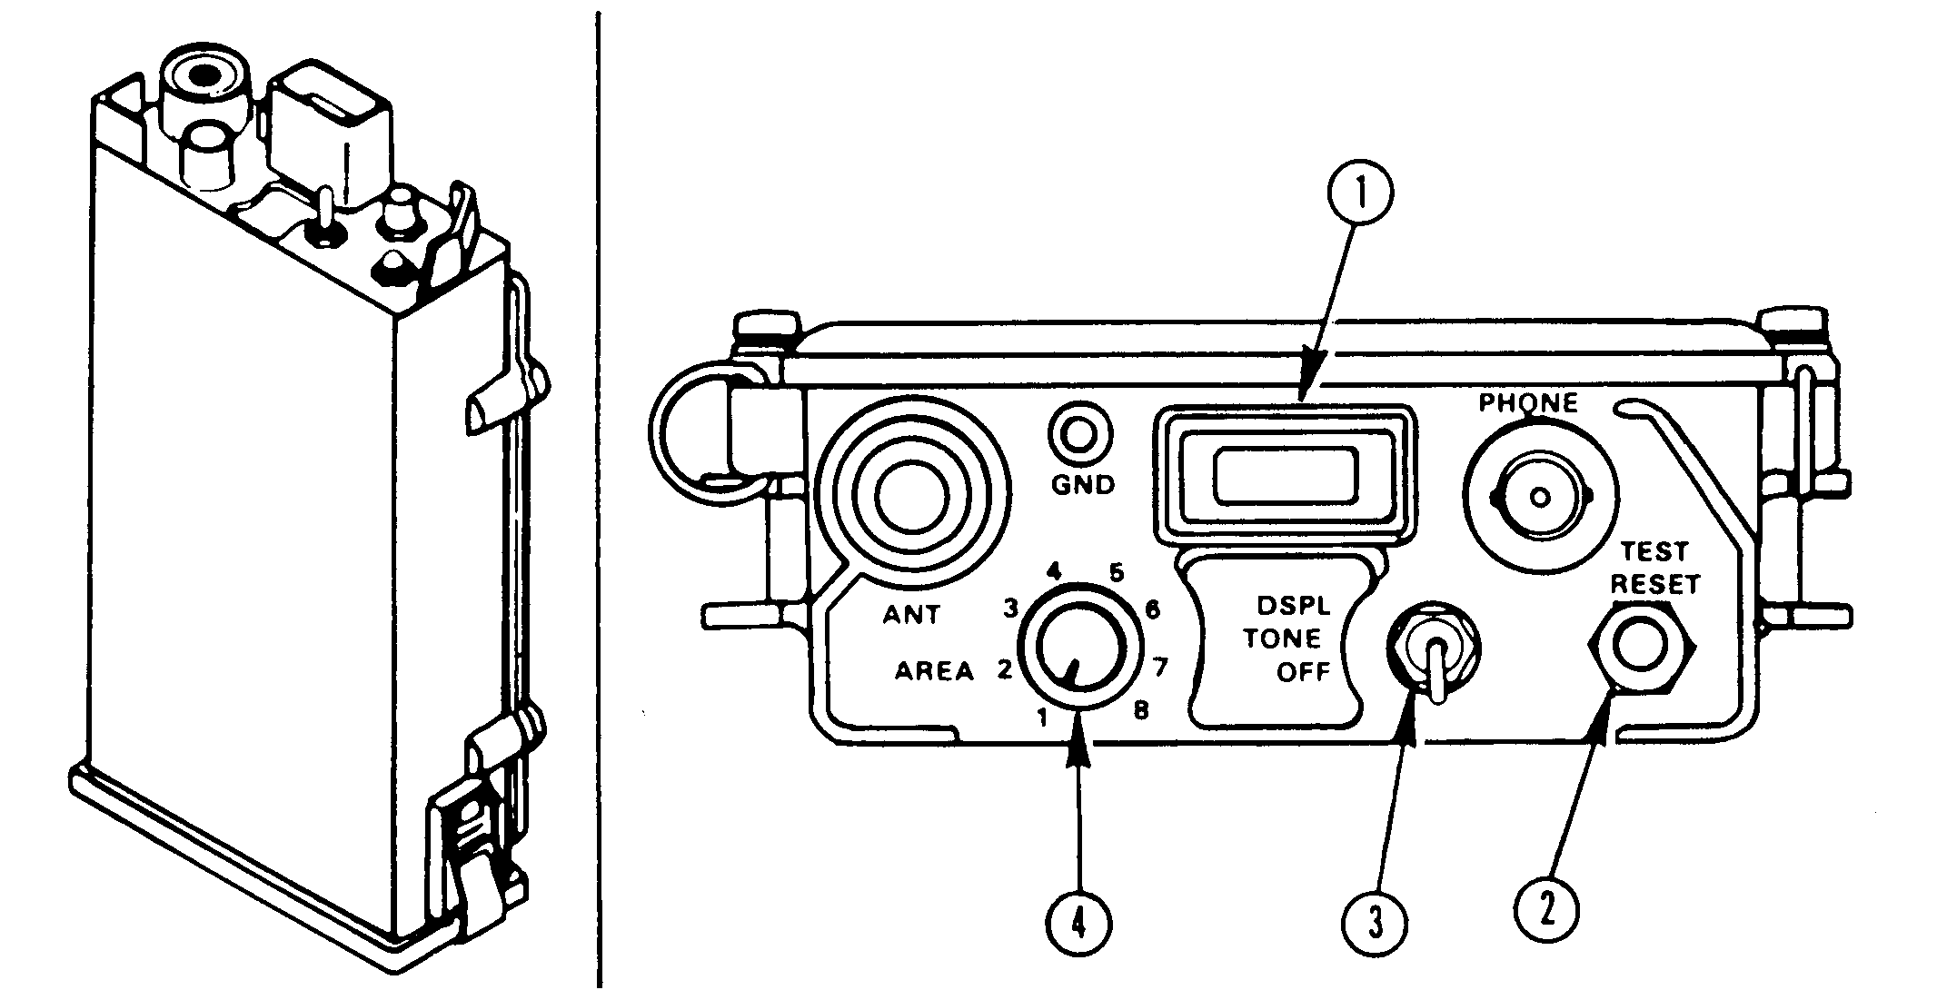

Figure 8. Receiver.

Note: The receiver in the RF mode will handle up to 16 detectors.

(2) The TEST-RESET button (2, Figure 8) is used to test the receiver battery and display. The button also is used to erase alarm messages from the receiver memory and to clear the display.
(3) The DSPL-TONE-OFF switch (3, Figure 8) has three positions.
(a) DSPL—A detector message is displayed and the tone is heard in the earphone of the headset when the detector message is received.
(b) TONE—The display is turned off but the tone is heard in the earphone when the detector message is received.
(c) OFF—Receiver power is shut off.
(4) The AREA switch (4, Figure 8) has eight positions. Each set of detectors is assigned an area number.

Notes: 1. For the PEWS to be used in the RF mode, the variation number on the receiver and detectors must be the same. The variation numbers are 1 to 6, and are found following the “V” in the equipment nomenclature. The variation numbers identify the operating (radio) frequency of the detectors and receivers (Figure 9).

2. A company may have receivers and detectors that all have the same variation number. Each platoon will be issued a different area number, which will keep one platoon’s receivers from receiving messages from another platoon’s detectors.

3. In the wire mode, the variation numbers do not have to be the same.

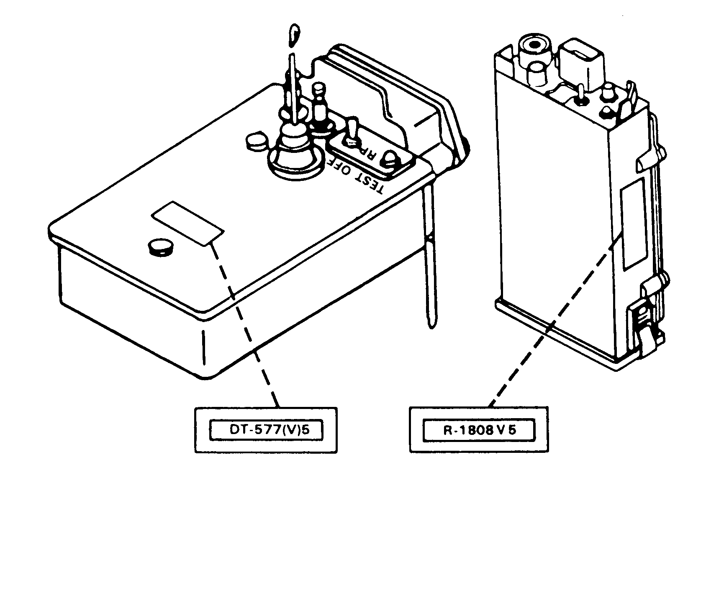
IDENTIFICATION PLATES

Figure 9. Receiver identification plate.

b. Detector (Figure 10, page 3-100).
(1) The antenna post (1, Figure 10) allows connection of the antenna to the detector.
(2) The data terminal posts (2, Figure 10) provide the connection of wire.
(3) The RF-OFF-W switch (3, Figure 10) has three positions.
(a) RF—Places the detector in RF (radio mode of operation).
(b) OFF—Turns off the detector power.
(c) W—Places the detector in the wire mode of operation.
(4) The TEST button (4, Figure 10) allows a check of the transmitter element of the detector.

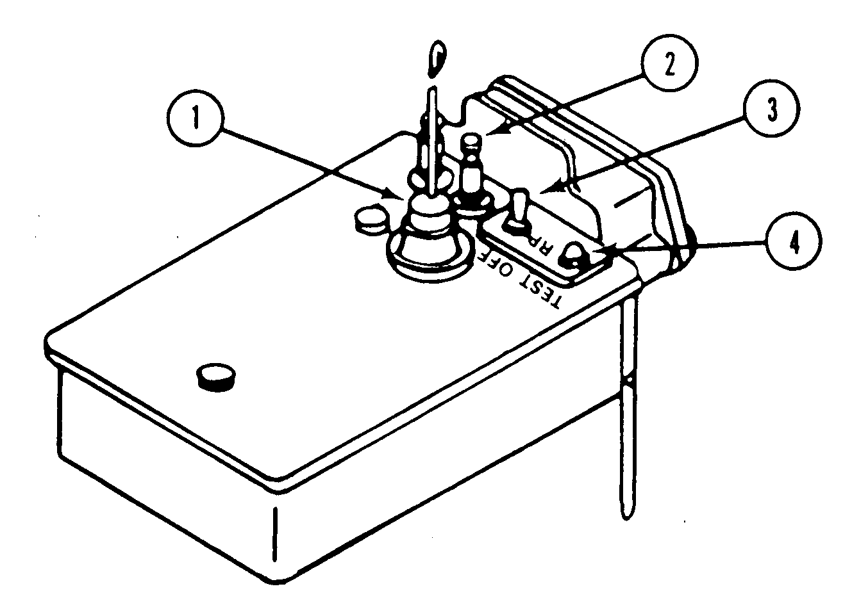

Figure 10. Detector controls.

c. Wire link (Figure 11).
(1) The connector (1, Figure 11) allows attachment of the wire link to the base of the receiver.
(2) The REC/TEST switch (2, Figure 11) has 10 positions.
(a) The REC (receiver) position is used during operation.
(b) The TEST positions 1 through 9 allow testing of field wire connections.
(3) The TEST IND light (3, Figure 11) lights when the REC/TEST switch is turned to a wire-pair number.
(4) WIRE terminals 1 through 9 (4, Figure 11) are used to connect field wire from the detector. The GND terminal (5, Figure 11) is used to attach the ground rod to the wire link.

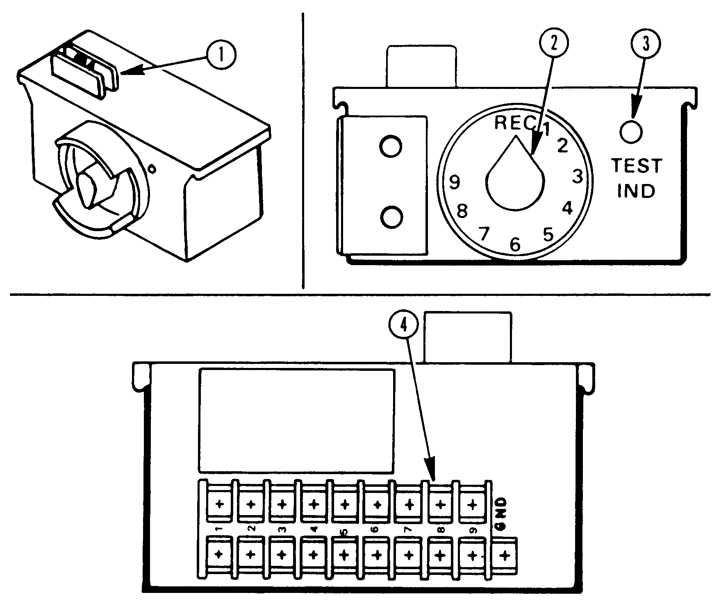

Figure 11. Wire link.

3. Preparation of the receiver (RF mode).
a. Install the battery (Figure 12, page 3-102).
(1) Set DSPL-TONE-OFF switch to OFF.
(2) Release the latches on the battery compartment at the base of the receiver.
(3) Snap two batteries into position in the battery compartment with the connectors against the rubber pad.
(4) Replace the cover and secure the latches.

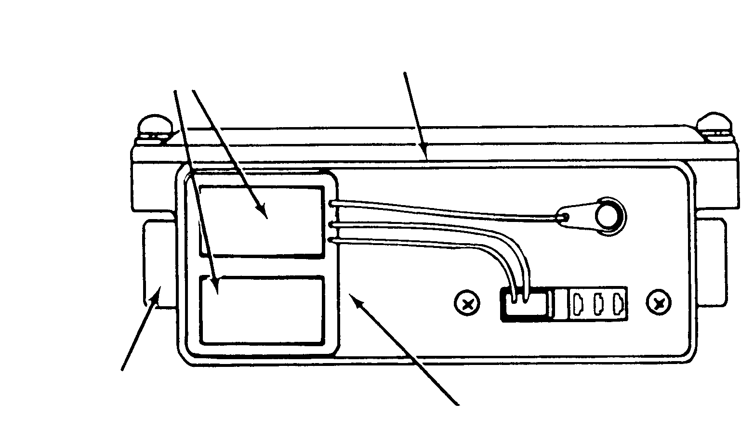
COVER REMOVED
BATTERY COMPARTMENT
BATTERIES
(BOTTOM)
LATCH
REAR VIEW

Figure 12. Receiver battery compartment.

b. Install the antenna/headset (Figure 13).
(1) Install the antenna adapter into the ANT socket on the front panel.
(2) Connect the antenna to the adapter (the antenna adapter has three sockets; the antenna can be connected to any one of them).

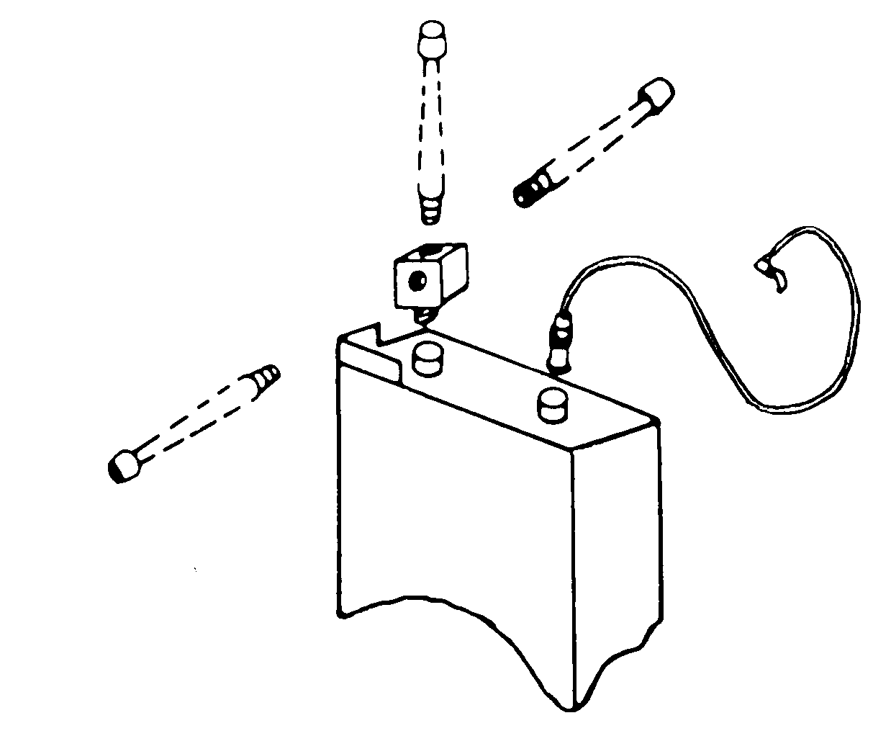
ALTERNATE POSITION

Figure 13. Receiver antenna installation.

4. Preparation of the detector (RF mode).
a. Install the battery (Figure 14).
(1) Set the RF-OFF-W switch to OFF.
(2) Loosen the screws to release the battery cover.
(3) Snap the battery into the clip and place it in the compartment with the connector against the pad.

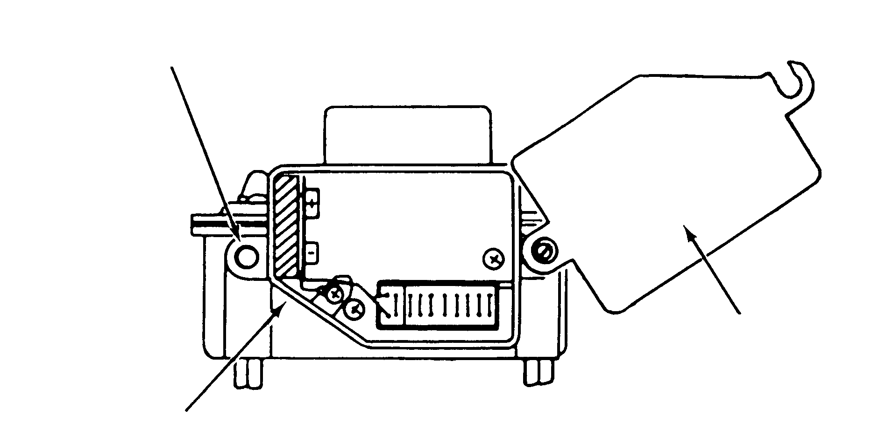
KNURLED SCREW
BATTERY COVER
END VIEW
PAD

Figure 14. Detector battery compartment.

(4) Check the number code and detector identification number on the inside of the battery compartment cover.

Note: All detectors within a set must have the same number code, and each detector must have a different identification number.

(5) Close the battery compartment and tighten the screws.
b. Install the antenna (Figure 15, page 3-104). Screw the detector antenna onto the threaded post on top of the detector.

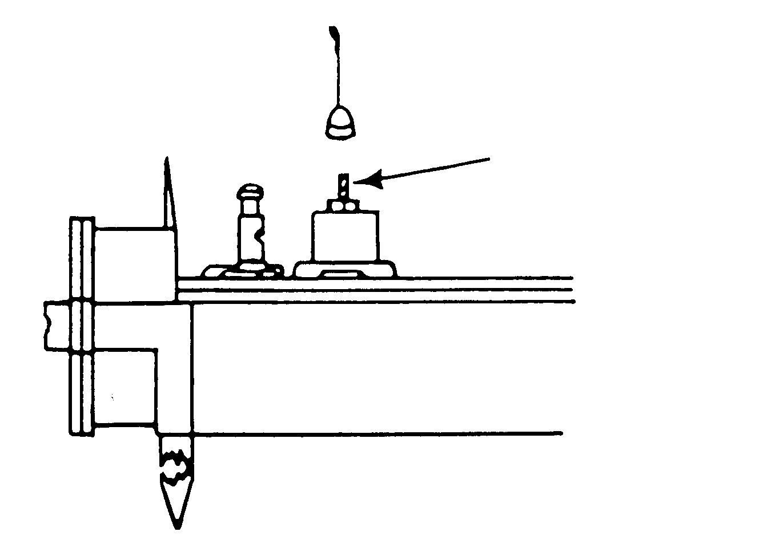
THREADED POST

Figure 15. Detector antenna.

c. Install the ground stake (Figure 16). Screw the ground stakes (2) into the bottom of the detector.

Note: Ground stakes should not be installed until the detector is to be placed in the ground.

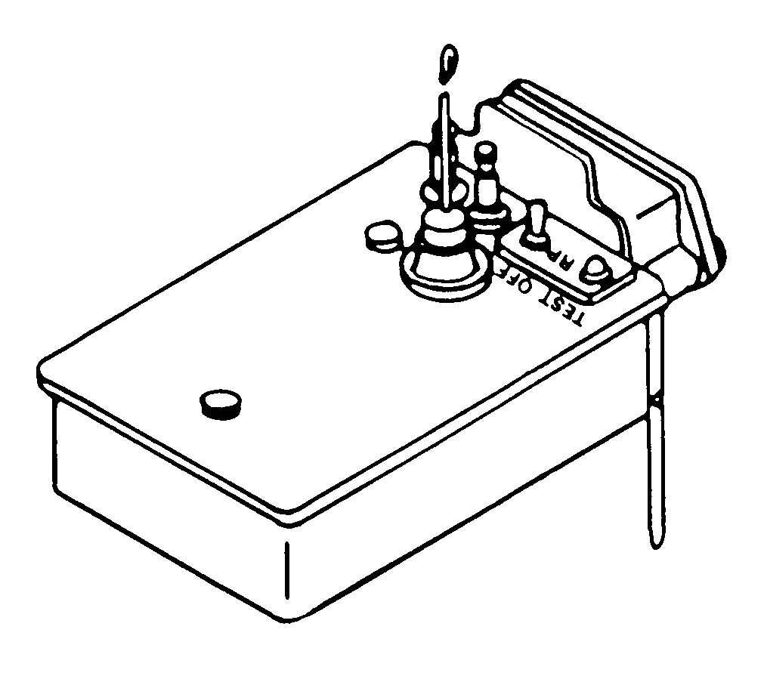

Figure 16. Detector ground stakes.

5. Preparation of the receiver (wire mode).
a. Prepare the receiver the same as for the RF mode including the installation of the batteries.
b. Remove the battery compartment cover and snap it onto the holding bracket on the wire link.
c. Secure the wire link to the bottom of the receiver using the wire link connector (Figure 17).
d. Secure the latches to the wire link.

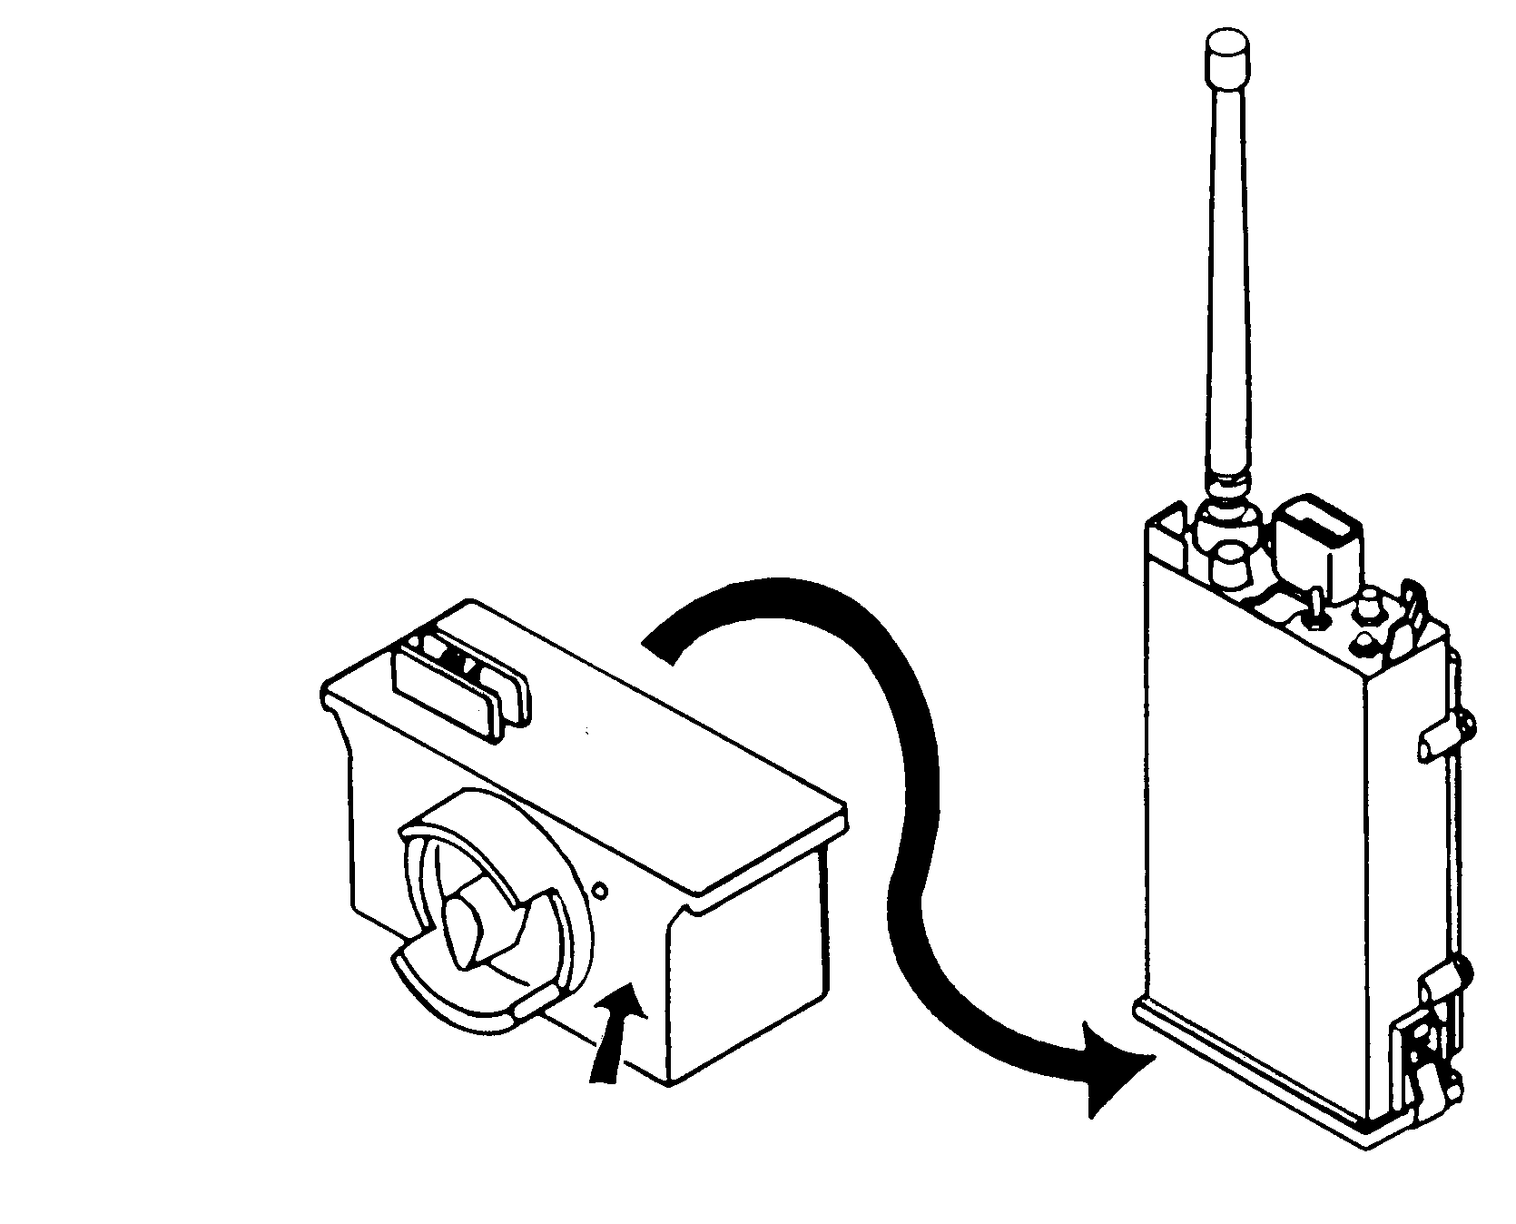
PUSH ON AND LATCH

Figure 17. Wire link secured to the receiver.

6. Preparation of the receiver and detectors is complete.

EVALUATION PREPARATION

Setup: At the test site, provide the equipment and situation given in the task conditions statement.

Brief Soldier: Tell the soldier to prepare the receiver and five detectors: four for RF mode and one for wire mode. Tell him to prepare the receiver for use.

EVALUATION GUIDE

Performance Measures Results

1. Check the variation numbers of the receiver and detectors. P F

2. Prepare the detectors for RF mode operation. P F

3. Prepare the detector for wire mode operation. P F

4. Prepare the receiver for both RF and wire mode operation. P F

5. Install the receiver headset. P F

FEEDBACK

Score the soldier GO if all steps are passed. Score the soldier NO-GO if any steps are failed. If the soldier fails any steps, show what was done wrong and how to do it correctly.

REFERENCES

Required Related
None TM 11-5895-1047-10

